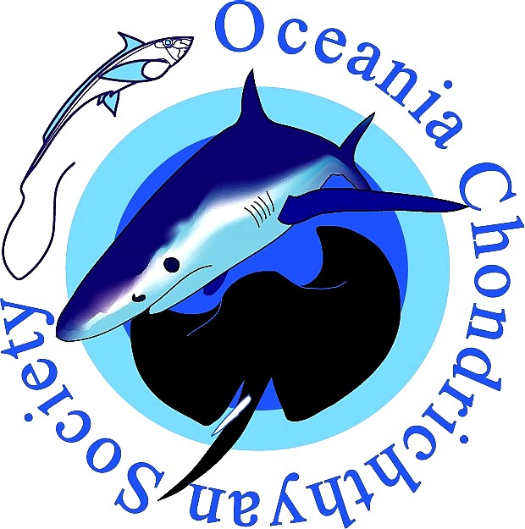
Application for OCS
Special Travel Award for IPFC 2017

Information about the OCS travel award
The OCS is providing two Special Travel Awards to help members travel to the 10th Indo-Pacific Fish Conference in Tahiti from 2-6 October 2017.
There are 2 grants to support airfare travel to the event up to a maximum of $2,000 AUD.
- One grant is to support a female student (honours, masters, or PhD) or Early Career Researcher (within five years of graduating from a postgraduate degree) to attend IPFC Session I1 Women in Marine Sciences in the Indo-Pacific.
- One grant is to support a postgraduate student (honours, masters, or PhD) to attend IPFC Session D2 Indo-Pacific Predators: biology, ecology, conservation and management.
Successful applicants will receive a cheque for the amount at the IPFC meeting. The two travel awardees must present a talk or poster at the listed IPFC sessions, must acknowledge the OCS as providing funding to support their travel. Instructions for applying for the OCS 2017 Special Travel Awards are as follows:
- Complete all fields in this form to the best of your ability and return via e-mail to the OCS secretary at: samantha.sherman@my.jcu.edu.au
- Applications will be assessed on the basis of the scientific merit of the research being presented, evidence of efforts to disseminate information about the project, and the potential benefit the applicant will gain from attending the meeting.
- Applications must be received by 05:00 pm AEST Friday 07 July 2017.
- Please note that these awards will be highly competitive and poor quality applications will not be considered.

Personal, research and presentation details
Name
Grant applied for | Session D2 Indo-Pacific Predators  Session I1 – Women in Marine Science
Career stage | Honours Masters PhD  Early Career Researcher (only application for applicants attending session I1)
University/Institution
Presentation title
Presentation type | Oral Poster
Describe the target audiences for your project outcomes – who needs to know about your project and why?
Brief research summary – what is your project about; what methods and approach were used; what findings will you present? (Maximum of 200 words, dot-point form preferable)
Have you communicated this data at a previous conference; in a peer reviewed journal; via mainstream media; via social media; industry briefings; public meetings etc? If so, please list these. If you have not already done so, what steps will you take to communicate this research? (500 words max)
What are your specific reasons for attending IPFC? How will you benefit from the meeting? Are you attending other side events or meetings during the travel, have you arranged meetings with collaborators etc? (500 words max)

Travel details
Departure city
Transit city (if applicable)
Estimated cost of travel

Any other comments or remarks?

If more than one flight/transfer etc. is required, please separate costs of each.

