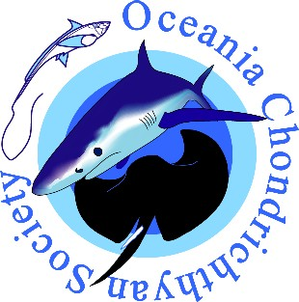
OCS Student Research Grant 2025
_____________________________________________

About the grant
The OCS awards a student research grant per year, despite having encountered difficulties to secure sponsorship during COVID and several post-pandemic years.

This year, Passions of Paradise and OCS are pairing up to provide $3,000 AUD towards a student research grant for projects in the Oceania region.

Criteria for eligibility and grant conditions
The following criteria and conditions apply to the OCS Student Research Grant 2025.
- The student must be enrolled in a university and be working towards a PhD or MSc on a topic involving research on chondrichthyans in the Oceania region.
- The grant may not be used to fund conference attendance or for travel that is unrelated to the research project.
- The recipient must have been a financial member of the society for 6 months before applying for the grant.
- The grant is not transferable and must be spent in the 2025-26 financial year.
- The research must not have been undertaken prior to application for the award.
- Successful applicants are required to prepare a one-page report for publication in the OCS newsletter at the end of the one-year grant period and provide a summary of how the research grant was spent.
- OCS must be acknowledged in all publications, posters, or presentations resulting from the project.

Proposals
Proposals of no more than four pages are invited from eligible students. Applicants must include the following information in the proposal.
- Applicant’s name, address, date of birth and current tertiary qualifications.
- University and faculty/school/department of enrollment.
- Name of supervisor(s).
- Project title and degree for which enrolled (MSc or PhD).
- Brief description of the project, stating:
  - Project aims and significance,
  - Methods, including project design,
  - Progress made to date,
  - Evidence of efforts to communicate research to managers, stakeholders, and/or the public
  - Clear indication of what the funding will be used for,
  - Expected year of completion and year in which enrolled.
- A detailed budget.
- List other sources of funding for the project.
Applicants must also provide a statement by the supervisor or a representative of the university, verifying that the project has been represented accurately and that the Institution is prepared to administer the award.

Assessment
Proposals will be assessed according to the Research Award Ranking Criteria (see document online) by judges selected by the OCS committee.

Proposal submission
Please e-mail proposals to the OCS Secretary at: executive4ocs@gmail.com
APPLICATIONS CLOSE 5:00PM AEST on FRIDAY 22nd of AUGUST 2025.
Applications received after 5:00PM AEST on 22nd August 2025 or that do not contain all the required information will not be considered.

The Oceania region includes Australia, New Zealand, Papua New Guinea and the Pacific Islands (American Samoa, Cook Islands, Federated States of Micronesia, Fiji, French Polynesia, Guam, Kiribati, Marshall Islands, Nauru, New Caledonia, Niue, Northern Mariana Islands, Palau, Pitcairn Islands, Samoa, Solomon Islands, Tokelau, Tonga, Tuvalu, Vanuatu and Wallis and Futuna Islands)

