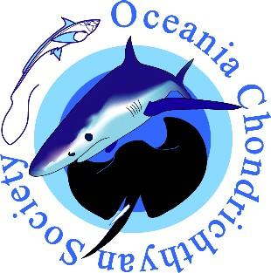
OCS Student Research Grant 2026
_____________________________________________
About the grant
The OCS endeavors to award a yearly student research grant to support members enrolled in Masters (MSc) or PhD programs.

In 2026, Passions of Paradise is generously sponsoring a $5,000 AUD research grant for projects in the Oceania region.

Criteria for eligibility and grant conditions
The following criteria and conditions apply to the OCS Student Research Grant 2026.
- The student must be enrolled in a university and be working towards a PhD or MSc on a topic involving research on chondrichthyans in the Oceania region.
- The grant may not be used to fund conference attendance or for travel that is unrelated to the research project.
- The recipient must have been a financial member of the society for 6 months before applying for the grant.
- The grant is not transferable and must be spent within 12 months of receiving the award.
- The research must not have been undertaken prior to application for the award.
- Successful applicants are required to prepare a one-page report for publication in the OCS newsletter at the end of the one-year grant period and provide a summary of how the research grant was spent.
- OCS must be acknowledged in all publications, posters, or presentations resulting from the project.
- The research grant does not include university or institution overheads.

Proposal
We invite proposals from eligible student members. Applications are limited to 4 pages and must include the following information in the proposal.
- Cover page (1 page):
  - Applicant Name;
  - University and Department;
  - Degree enrolled in;
  - Supervision;
  - Expected date of completion;
  - Statement of support by the supervisor (~200 words).
- Project details (2 pages):
  - Project title;
  - Project aims and significance;
  - Methods, including project design;
  - Any progress made to date e.g., permits approved, samples collected, laboratory contacted;
  - Expected outcomes & impact;
  - How will this be communicated e.g., to managers, stakeholders, and/or the public;
- Budget (1 page)
  - Detailed budget;
  - Clear indication of what the funding will be used for;
  - List of other sources of funding for the project.
Applications
Please e-mail proposals to the OCS Secretary at: executive4ocs@gmail.com
APPLICATIONS CLOSE 5:00PM AEST on FRIDAY 2nd of October 2026.
Applications received after 5:00PM AEST on 2nd October 2026 or that do not contain all the required information will not be considered.

Assessment
The OCS committee will select a panel of judges to assess proposals based on the following criteria: eligibility & proposal requirements, readability of the application, project description, scientific merit & originality, and budget.
Applicant Name

Enrolled Program

University and Department
Supervisor(s)

Expected Date of
Completion
Applicant Signature
OCS Student Research Grant Cover Page

Supervisors’ statement of support
Please include a short ~200 word statement verifying that the project has been represented accurately and that the Institution is prepared to administer the award.
Supervisor Signature: | Date:

